HOMEWORK ASSIGNMENT #4 ORGANIC CHEMISTRY I (30 pts) Branched and Cycloalkane naming; Conformational Analysis (due Wednesday 27 September 2017)
Your name: ____________Answers______________________________________
1

1) Text Problem (2 points each/14 points total)
4.36c______2-methyl-4-propyloctane_______________________________________
1

4.36d_____4-(1,1-dimethylethyl)heptane__________________________________
1

4.36f_______3-ethyl-6-(1-methylethyl)-2,4-dimethyldodecane________________
1
4.36g_____3,5-diethyl-2-methyloctane____________________________________
1
4.36i______1,2,4,5-tetramethyl-3-propylcyclohexane_________________________
5

4.36k______1,4-dimethylbicyclo[2.2.2]octane________________________________________

2) Text Problem (1 pt each/2 pts total)
1

4.37a constitutional isomer or same (just different rotational conformer)

4.37c constitutional isomer or same (just different rotational conformer)

3) Text Problem 4.43a (2 pts)

Ring flip=>
Axial equatorial
Equatorial axial

3) Text Problem 4.47a (2 pts)
C3
C2

3-ethyl-2,3-dimethylpentane

4) Text Problem 4.48c (3 pts)
methylcyclopentane
Axis of Neumann
projection
5)Text Problem 4.51b (2 pts)

6) Text Problem 4.56 (2 pts) [Label compounds A-D left to right] __D__<__A__<__C__<__B__
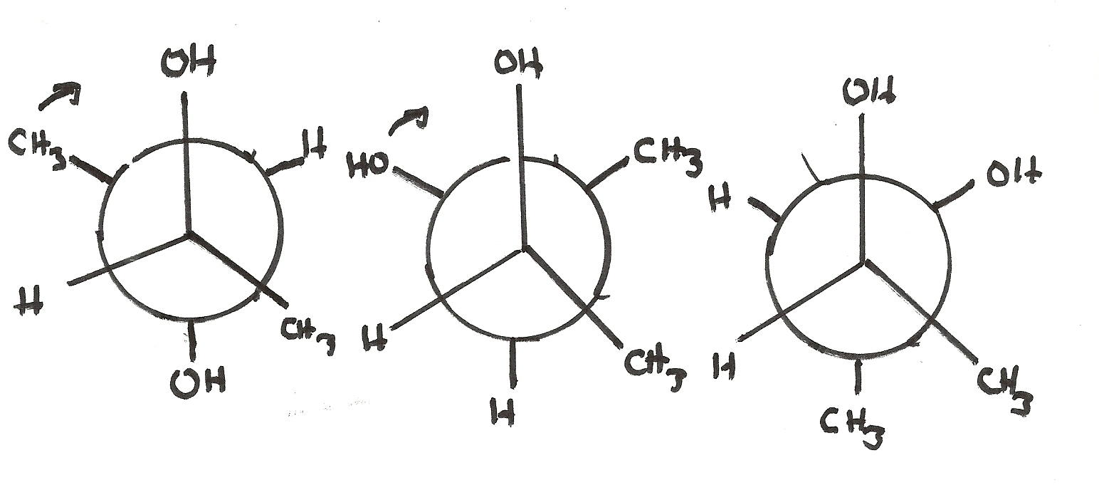
7) Text Problem 4.75 (3 points)
A most stable. OH and CH₃ both anti to opposite OH and CH₃
B,C are the same and higher in energy since OH---OH, CH₃---CH₃
are gauche to each other in both B and C
A B C

